Setting up Application Environment

Docker CLI Installation

|  |  |
| --- | --- |
| Team ID | PNT2022TMID33459 |
| Project Name | Personal Expense Tracker Application |

**Step 1:**

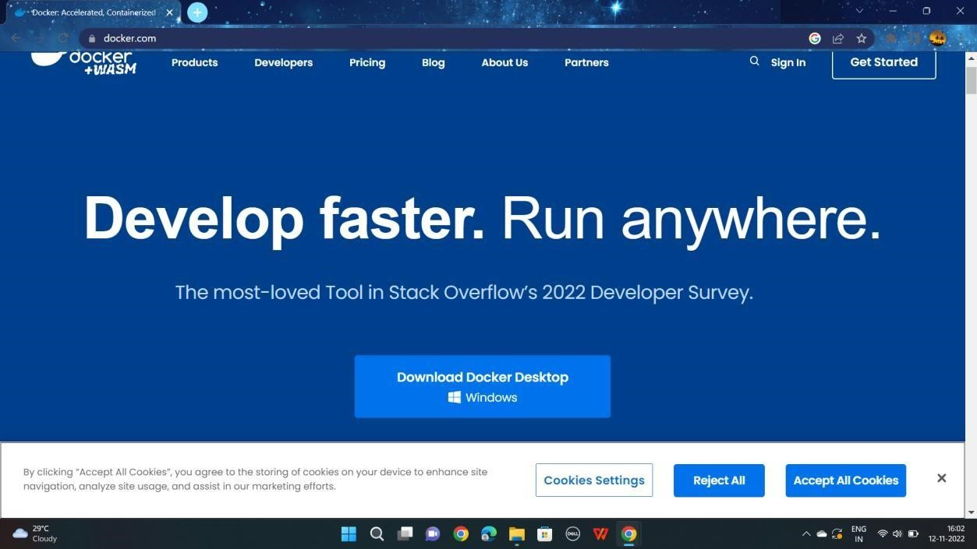

**Step 2:**

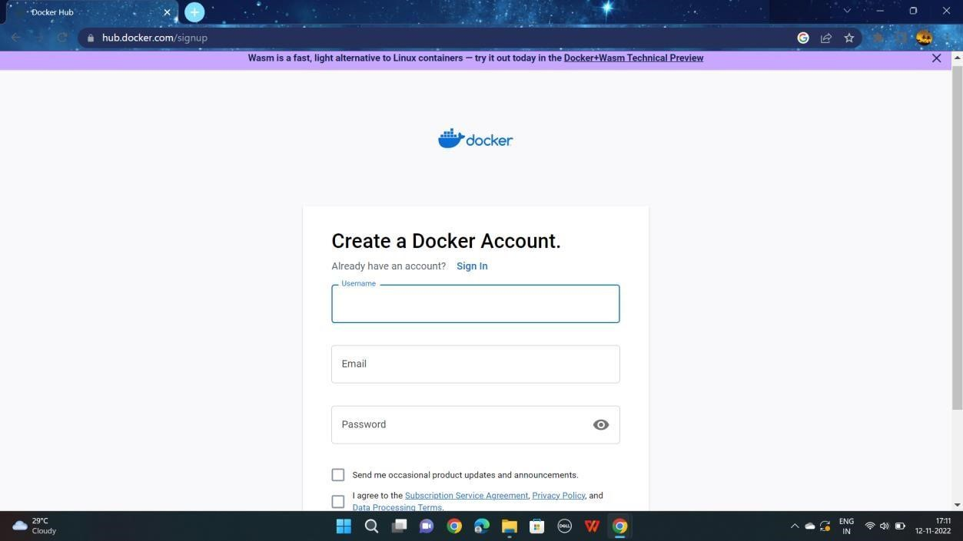

Setting up Application Environment Docker CLI Installation

**Step 3:**

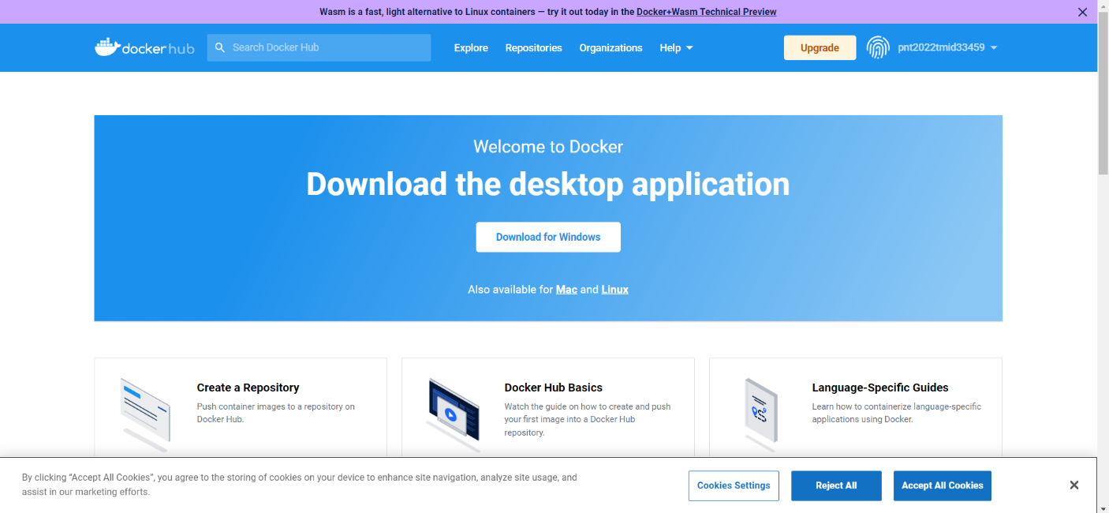

**Step 4:**

